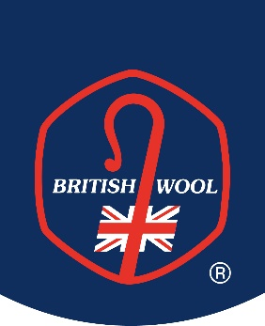
British Wool – Self-Billing Agreement
Please complete and return one copy to the address below to accept the Self-Billing procedure with British Wool. Retain the second copy for your records.
Member Services, British Wool, Wool House, Sidings Close, Canal Road, Bradford, BD2 1AZ
Tel: 01274 688666 memberservices@britishwool.org.uk www.britishwool.org.uk

This is an agreement to a self-billing procedure between:
Customer Name: British Wool Marketing Board VAT number: GB 264533990 and
Producer Name
Producer VAT Number
British Wool Registration number

The self-biller (the Customer - British Wool Marketing Board) agrees:
- To issue self-billed invoices for all supplies made to them by the self-billee (the Producer) from the onset of business relations until the registration of the Producer with British Wool Marketing Board ends.
- To complete self-billed invoices showing the Producer’s name, address and VAT registration number, together with all the other details which constitute a full VAT invoice.
- To make a new self-billing agreement in the event that their VAT number changes.
- To inform the Producer if the issue of self-billed invoices will be outsourced to a third party.

The self-billee (the Producer) agrees:
- To accept invoices raised by the Customer (British Wool Marketing Board) on their behalf until the Producer’s registration with British Wool Marketing Board ends.
- Not to raise sales invoices for the transactions covered by this agreement.
- To notify the Customer (British Wool Marketing Board) immediately if they;
  - Change their VAT registration number.
  - Cease to be VAT registered.
  - Sell their business or part of their business.
Signed by:
Customer | Producer
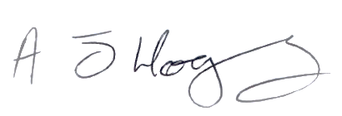 | Signed by
Andrew Hogley, CEO | Print name
On behalf of  British Wool Marketing Board | On behalf of
22 February 2024 | Date

